[Year]
DMUIC

Name: Tarik Hamza Bilgin
Student No: P2887767
Module: Operating Systems and Networks - LIPC1265_2024_503
Tutor: Dr. Zainab Pirani and Prerana Battepet Hari Prakash
Log Book
Word Count: 1042
Date: 5/12/2024

ENTRY NO 1 | WEEK NO 3 | TASK
Title: |  | Understanding the Operating System in Cisco Packet Tracer
Activities and Observations:
In a small activity that I made, three network topologies were simulated to show how they worked from one device to another. I observed that this program can be used to simulate network systems before applying them in real life to see if the network structure would be optimal.

Challenges:
Some of the various challenges faced when using the program were that many functions make it complicated for beginners and can be confusing when searching for something specific.
Insights/Learning:
From my research, I learned that the OS in the Cisco packet tracer is proprietary, the name of the OS is Cisco IOS (Internetwork Operating System). This OS supports tasks that need to be done in networking by displaying all aspects of networking required to make it work, and a unique feature of this program is that it can visualise packet flow and simulate complex scenarios for real-life implementation. In comparison, Windows is a general-purpose OS that is very user-friendly for basic networking tasks but requires additional programs for more advanced tasks, and as for Linux, it is highly customisable and has powerful command line tools, which makes it an optimal networking for experts but is very difficult to learn.
Data acquisition and extrapolation:

Reading Materials/Resources:
Zola, A. and Scarpati, J. (2023) What is Cisco IOS software, and how does it work?: Definition from TechTarget, Networking. Available at: https://www.techtarget.com/searchnetworking/definition/Cisco-IOS-Cisco-Internetwork-Operating-System#:~:text=Cisco%20IOS%20(Cisco%20Internetwork%20Operating%20System) (Accessed: 20 October 2024).

ENTRY NO 2 | WEEK NO 5 | TASK
Title: |  | IP Address & Number System Conversion
Activities and Observations:
After some research, I have decided to use class C IP address for this project, because it is the most optimal choice for hosting 254 users in a private Ip address network, which is more than enough.
Challenges:
A slight challenge that I had in converting the Ip address from decimal to binary and hex was that I was not sure if I had written the results in correct form.
Insights/Learning:
In this entry I refined my skills in calculating numbers of binary, decimal and hex. I learned what each number in an Ip address represented more clearly.

Configuration and Network details:
The decimal format of IP address I am using is 200.200.200.1.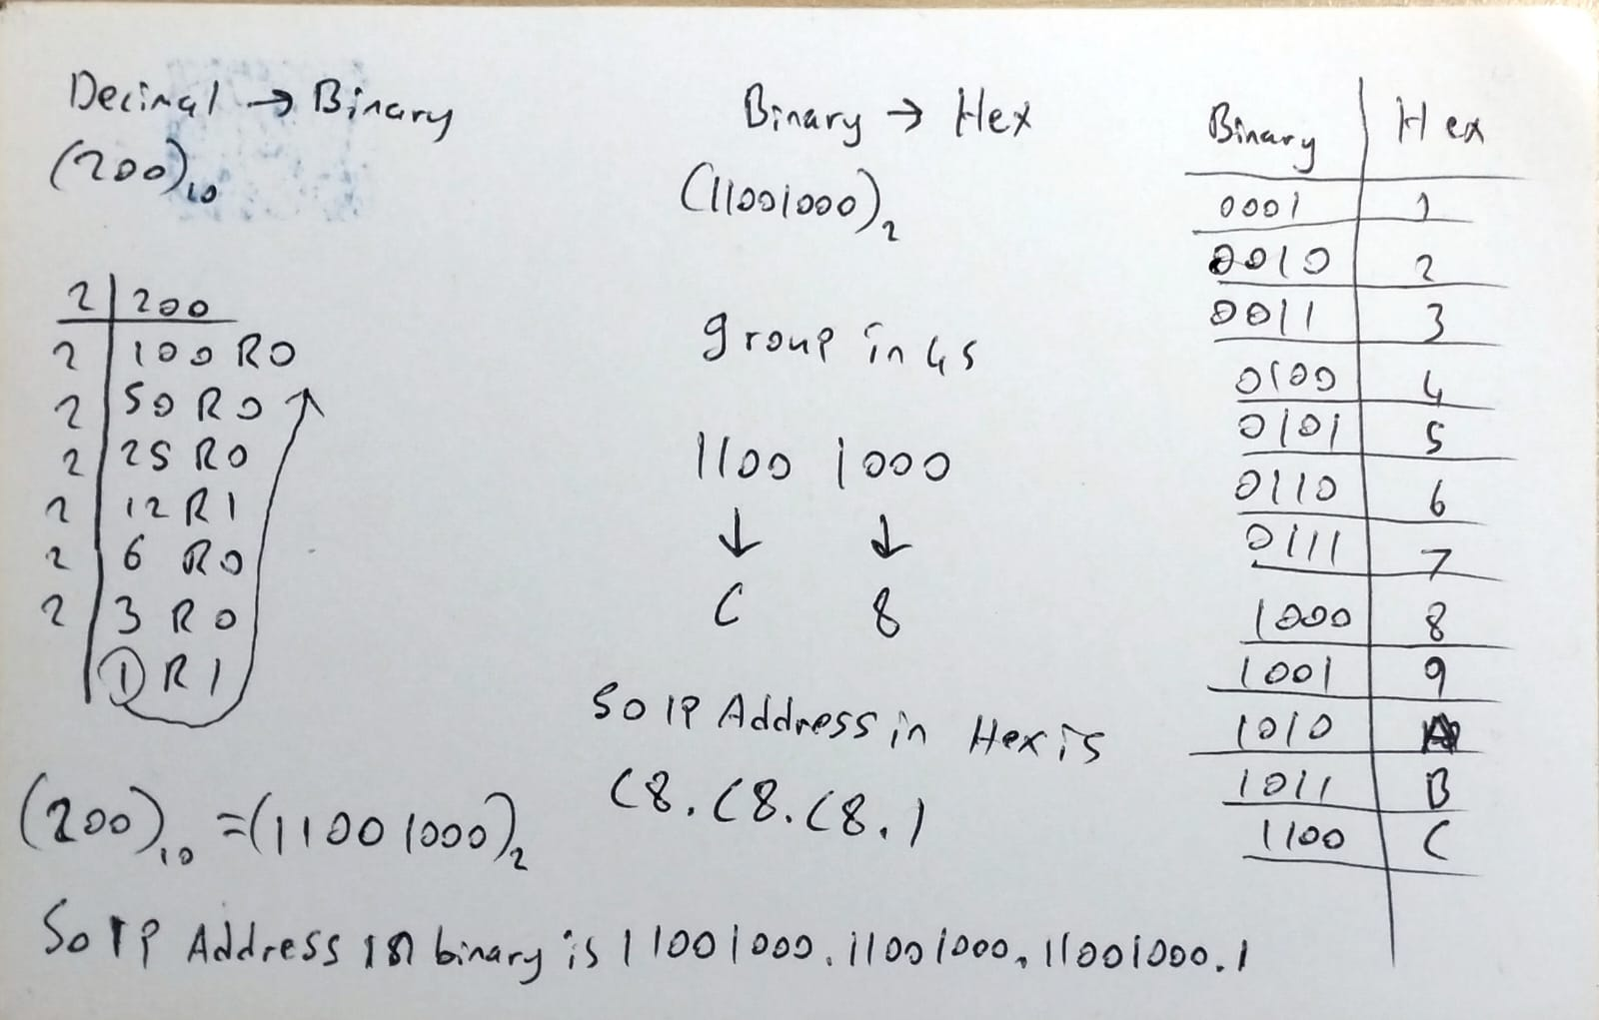
IP address in binary is 11001000.11001000.11001000.1 and in hex numbers C8.C8.C8.1. These results were obtained from the image above. Additionally, the number 1 has not been calculated for the binary or hex numbers because the number 1 is the same in all decimals, binary and hex numbers.
Reading Materials/Resources:
https://youtu.be/rsxT4FfRBaM

ENTRY NO 3 | WEEK NO 7 | TASK
Title: |  | Network Topologies & Cables
Activities and Observations:
After trying all the types of network topologies, I decided to use star topology. This is because it is reliable and sustainable. But the way I intend to implement is going to cost about (240$), and that is just the switches, which is a bit costly. Comparing the use cases of the existing cables, I chose to use ethernet cables, because I will not be needing to use cables over long distances and need it to be flexible.

Challenges:
Setting up the router was a major challenge I faced, due to its difficulty setting up its connectivity being something new, as such it was hard.
Insights/Learning:
I learned how to set up and connect a router to each other.
Configuration and Network details:
Each department will have a switch that connects to a router that connects the buildings to each other. So, in this project switches and routers will be used for the networking devices. Ethernet cables will be used to connect end devices to switches and switches to routers. I chose these because they all fit the needs of being fast, reliable and mostly cost effective
Reading Materials/Resources:
Rendell, C. (2013). Network Topologies: Types, Performance Impact, and Advantages/Disadvantages. eBook Collection (EBSCOhost). Available at: EBSCOhost Link (Accessed: 14 November 2024)

ENTRY NO 4 | WEEK NO 9 | TASK
Title: |  | CLI Commands for Network Configuration
Activities and Observations:
I practiced using command line interface in cisco packet tracer with commands that are used in real life which gave me first-hand experience on how a CLI is used in networking.

Challenges:
It is much harder to use command line interface compared to a graphical user interface system.

Insights/Learning:
I learned that picking the right colours and making sure the site works on all devices is important. I also found out that knowing CSS well and fixing problems is key to getting the design right. Practice and patience are needed to improve these skills.

Configuration and Network details:
This command gives access to privileged exec mode

This command changes privileged exec mode to global configuration mode

This command gives access to a specific interface configuration (for example GigabitEthernet0/0/0)

This command assigns an IP address to a interface in this format : ip address <ip adress> <subnet mask>

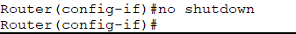
This is a command that activates an interface so that it starts transmitting and receiving traffic

Creates a static route

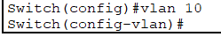
Creates a vlan to segment a network

Encrypts the privileged exec mode
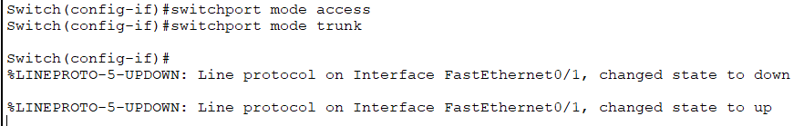
The first command changes the mode of the selected port on a switch from trunk to access
The second command changes the mode of the selected port from access to trunk mode.

Reading Materials/Resources
https://www.youtube.com/watch?v=Ggebt-cr8RM
https://www.youtube.com/watch?v=L6XzxMEGgzs

ENTRY NO 5 | WEEK NO 10 | TASK
Title: |  | Final submission and conclusion
Activities and Observations:
Working on this project with a group partner was quite a new experience that expanded my vision and horizons. It was quite the trial that tested my patience, perseverance, research skills and cooperation ability with other people. I configured many switches and routers for the first time in my life which was an eye opener. For the next time I would probably try to do way more research and prepare much more and be ready for anything.
Challenges:
Setting up the routers was quite a hassle because I was doing it for the first time, and working with someone else who had different ideas and views was a bit complicated. Also setting up the complete structure of the project was difficult for me, as in the combining of the departments using a router at the centre didn’t work the first time I tried it so I tried using a main switch then connect it to a router but it was much more complicated than I thought so I researched and found a router that fit my needs at the last day of the project submission which was terrifying.
Insights/Learning:
I obtained valuable networking skills and cooperation capabilities which will definitely aid with at least basic networking tasks and opened a path for further enhancing my abilities in this path.
Configuration and Network details:

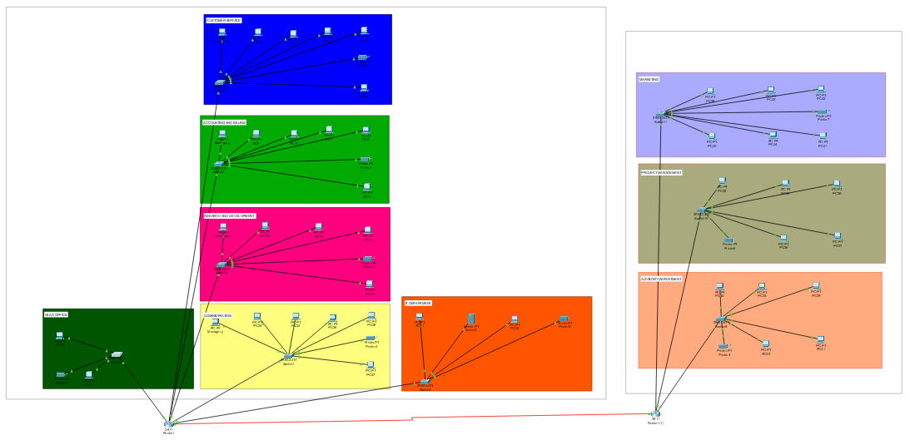
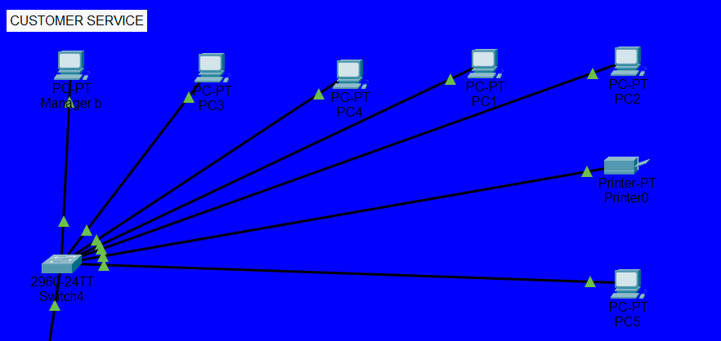
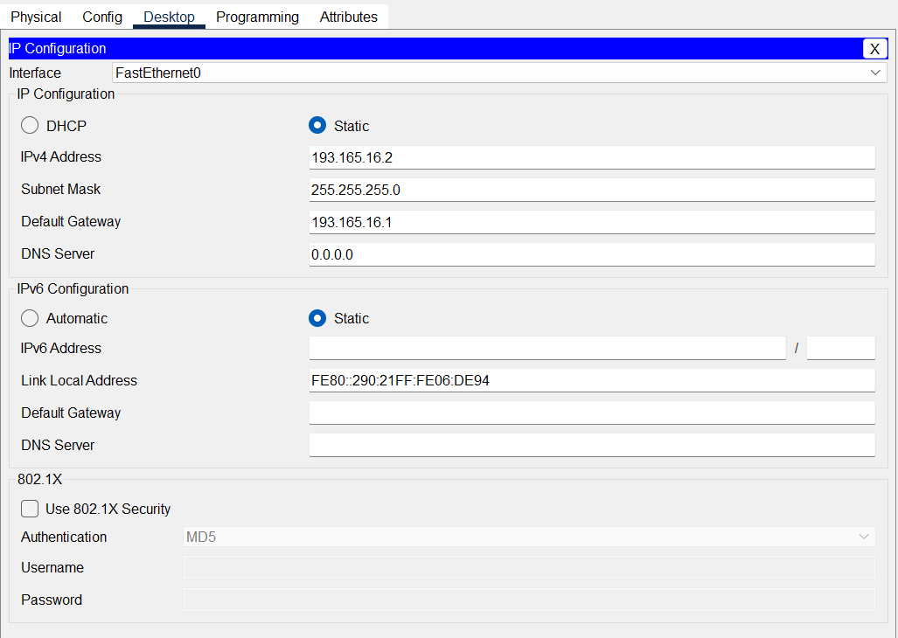
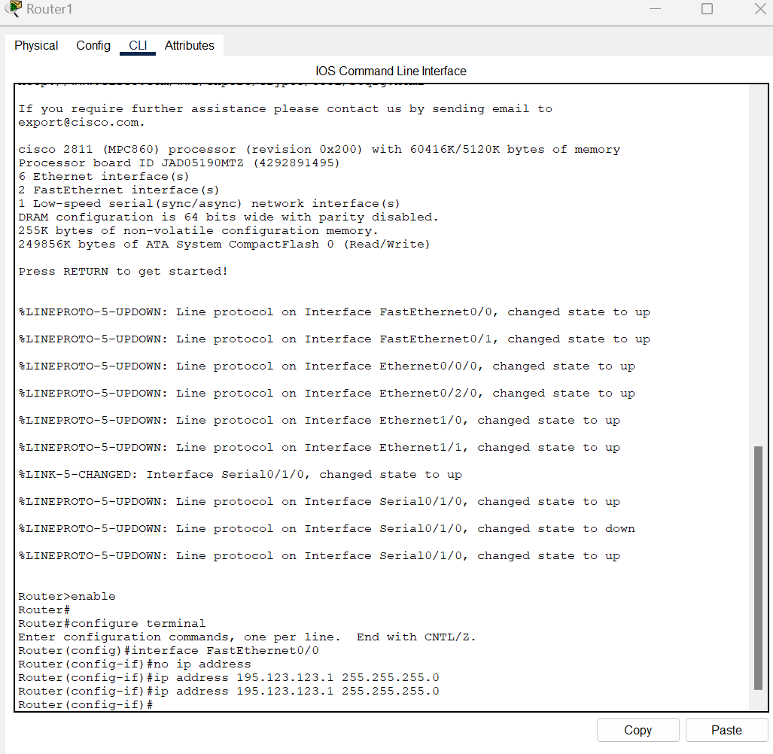
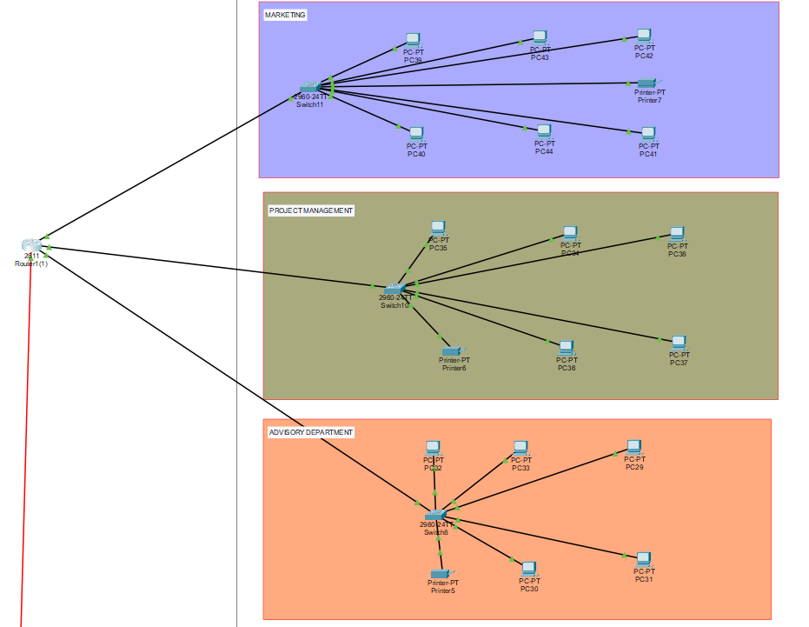
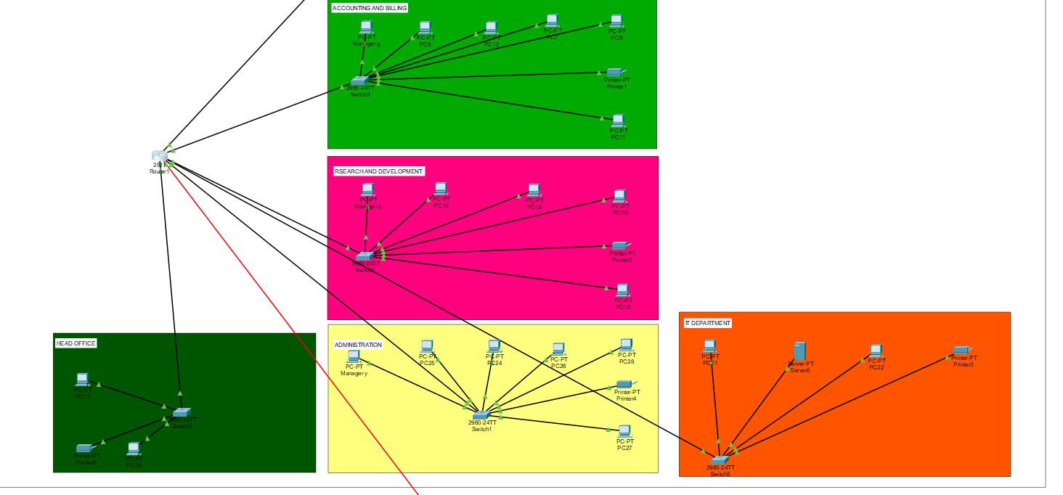

Reading Materials/Resources

